**Touch switch Light on/off**

**Introduction**

we use a touch sensor that acts as a switch whenever we touch it. We have to touch the sensor in order to on the LED. he touch sensor that we use in our project is the **TTP223** capacitive touch module that offers a one-touch key. The touch sensor generates a HIGH output when we touch it on its surface and LOW output for normal conditions.

In this sensor, there are two plates with ‘Co’ as the capacitance. When the human touch is identified, the touching part to the sensor is referred to as a conducting object and the capacitance is denoted as CT. The ‘Co’ is monitored continuously by using measuring equipment as the change in the capacitance is detected, it will be converted in the form of a signal.

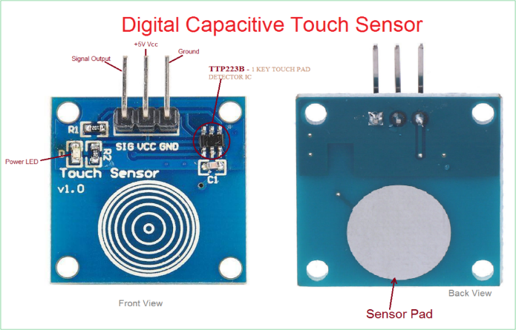

**Components**

Arduino uno

Touch sensor

Jumper wire

led

**Application**

* Water proofed electric products
* Button key replacement
* Consumer products
* water taps such that with one touch
* mobile phones, monitor screens, control panels,

**Objective**

During this activity ,you will help students to achieve following objectives

1. Understanding the principle and operation of ultrasonic touch sensor
2. Design algorithm and flowchart to detect sensed voltage and provide electrical output
3. Programming Touch sensor using Arduino uno
4. Interfacing Touch sensor withArduino uno

**Programming steps**

1. Initialise touch sensor anallog input data as port A4
2. Initialise LED and relay as output device
3. If we touched on sensor,then it will send signal to Arduino,and It will on relay
4. Relay is electrical switch to turn LED on,whwn signal received LED will get ON

**Programming**

#define touchpin 4 // sets the capactitive touch sensor @pin 4

int ledPin = 2; // sets the LED @pin 2

void setup() {

pinMode(touchpin, INPUT); //sets the touch sensor as input

pinMode(ledPin, OUTPUT); //sets the led as output

}

void loop() {

int touchValue = digitalRead(touchpin); //reads the touch sensor signal

if (touchValue == HIGH){ //if sensor is HIGH

digitalWrite(ledPin, HIGH); //LED will turn ON

}

else{ //otherwise

digitalWrite(ledPin,LOW); //LED is turned OFF

}

delay(300); //delay of 300milliseconds

}

Hardware

Instructions

* Connect the VCC pin of the touch sensor to the voltage source terminal(+) in the breadboard.
* Connect the GND pin of the touch sensor to the common ground terminal(-) in the breadboard.
* Connect the SIG pin of the touch sensor to pin number 4 of the arduino uno board
* Connect positive pin of LED to digital pin 2 and negative end to ground

